## Changing Default Text Settings

By default RapidPlan will create Arial 14pt text. This can be changed through the RapidPlan Preferences screen or from within the Properties palette.

## To set a new Default Font through the Preferences Screen

* From the main menu Select **Tools** > **Preferences**.
* Select the **Defaults** tab (see below).
* Scroll down to the Fonts and Text section.
* Set the font as you require or set any other parameters you desire.
* Exit Preferences by closing its tab.
* 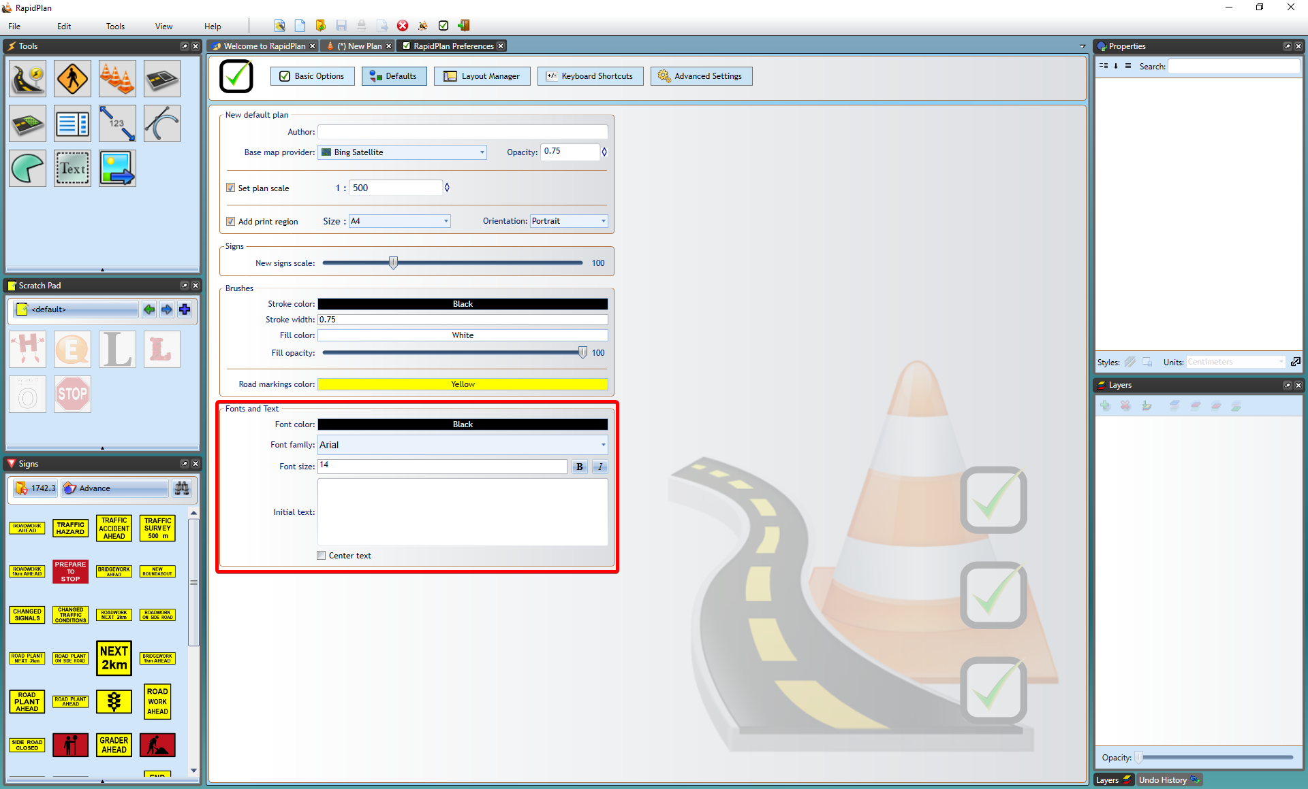
* Font_Default_Preferences

## To set a new Default Font through the Properties Palette

* Select the **Text Object** tool from the Text tab.
* Click on the canvas and enter you text in the allocated area.
* Use the Properties Palette to set the font as you require or set any other parameters you desire.
* Click **Save as Default Style** at the base of the palette when complete.
* 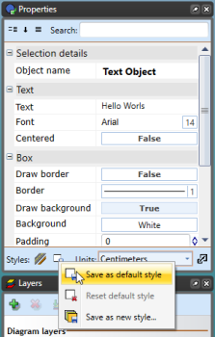
* Saving_New_Default_Font_in_the_Properties_Palette